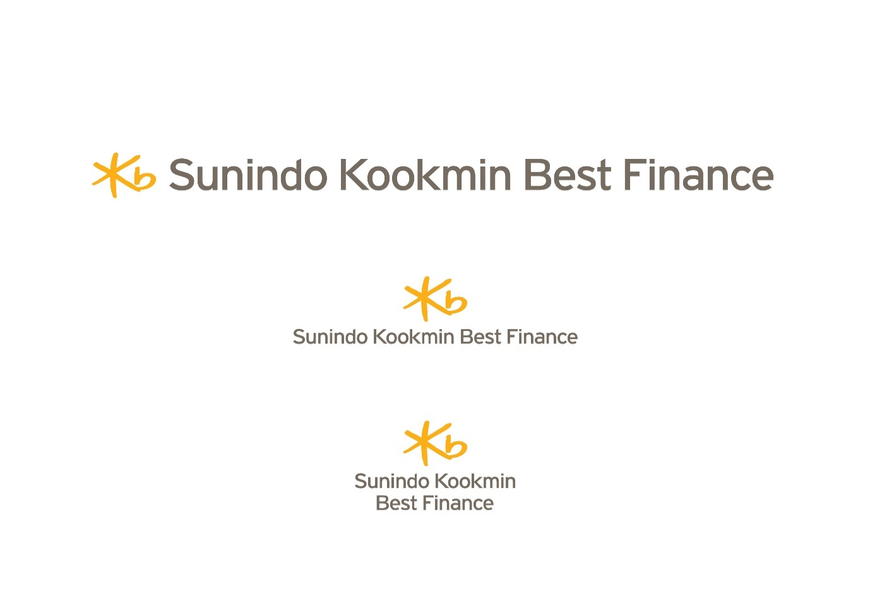

**APPLICATION FOR EMPLOYMENT**

**(This application form must be hand written by the application in English & not returnable)**

PHOTO

Position apply for 1.………………………………………………

2.………………………………………………

**Personal Particulars**

Name (in English) ……………………………….………………… Nickname……………….

Age…….……Date of birth……………Place of birth………… Nationality………….………

Occupation.………………….. Tel No………………………Mobile…………………………

Present address: …………………..…………………………………………………………….

E-mail address……………………………...Facebook…………………………………………

Gender……………......Height………………………. (cm) Weight……………………….(Kg)

Blood Group……………............................Religion....................................................................

**Family**

Marital status: Single Married Widowed Separated Divorced

If married, please complete the following:

Spouse’s Name………………………….No. Children…………...Boy(s)………………Girl(s)

Spouse’s Occupation……………………Name of Employer…………………………………..

|  |  |  |  |  |
| --- | --- | --- | --- | --- |
| Name of Parents | Sex | Age | Occupation | Name of Employer/School |
| Father | M |  |  |  |
| Mother | F |  |  |  |
| Name of Brothers/Sister |  |  |  |  |
|  |  |  |  |  |
|  |  |  |  |  |
|  |  |  |  |  |
|  |  |  |  |  |
| Name of your children |  |  |  |  |
|  |  |  |  |  |
|  |  |  |  |  |
|  |  |  |  |  |

**Educational/Professional Qualifications**

|  |  |  |  |  |
| --- | --- | --- | --- | --- |
| Name of Institution  (from Primary School Onwards) | Duration | | Level/Degree | Faculty/Subject |
| From | To |
|  |  |  |  |  |
|  |  |  |  |  |
|  |  |  |  |  |
|  |  |  |  |  |
|  |  |  |  |  |
|  |  |  |  |  |

**Employment History**

|  |  |  |  |  |  |
| --- | --- | --- | --- | --- | --- |
| Name of Employer/Company | Last Position Held | Last Drawn salary | Date | | Reason for leaving |
| From | To |
|  |  |  |  |  |  |
|  |  |  |  |  |  |
|  |  |  |  |  |  |
|  |  |  |  |  |  |
|  |  |  |  |  |  |

**Communication Competency**

(Please write down in 5 scale; 1=Poor, 2=Fair, 3=Average, 4=Good, 5=Excellent)

|  |  |  |  |  |
| --- | --- | --- | --- | --- |
| Languages | Listening | Speaking | Reading | Writing |
| Indonesia |  |  |  |  |
| English |  |  |  |  |
|  |  |  |  |  |
|  |  |  |  |  |
|  |  |  |  |  |

**OA Competency**

|  |  |  |
| --- | --- | --- |
| PowerPoint | Excel | Word |
|  |  |  |

(Please write down in 5 scale; 1=Poor, 2=Fair, 3=Average, 4=Good, 5=Excellent)

**Hobbies/ Sport**

|  |  |
| --- | --- |
| Hobby | Sport |
| 1. | 1. |
| 2. | 2. |
| 3. | 3. |

**Name of Referees (Must not be your relative or staff of SKBF Company)**

|  |  |  |  |
| --- | --- | --- | --- |
| Name of Referees | Occupation | Years Known | Address and telephone number |
|  |  |  |  |
|  |  |  |  |

**Should you be selected please indicate**

1. Expected salary……………………………………………
2. Period of notice required………………………………......
3. Date able to commence duty………………………………

**Personal Statement**

|  |
| --- |
|  |

I hereby declare that the particulars and answers given in this application form are to the best of my knowledge and belief true and correct. I understand that the company reserves the right to terminate my service without notice or compensation at any time should the company discover that any of the said particulars and answers were false, untrue or incorrect at the time of completion of this form.

Signature of Applicant……………………………… Date: ……………….